Insert your name, centre number and candidate number into the header above.
Save this evidence document as evidence_ followed by your centre number_ candidate number, for example: evidence_ zz999_9999.doc
Screenshots or program listings must be copied into appropriate cells in the following tables.
Examiners must be able to read the contents, including any screenshots, without the use of a magnifying glass. Answers that are not readable or are missing will not be awarded any marks.
Save this evidence document at regular intervals, for example every 10 minutes.
Question 1
Part 1(a)
Jobs = [] # global 2 dimentional array of type integer, 100 by 2 elements
NumberOfJobs = 0 # global integer

Part 1(b)
def Initialise():
global Jobs
global NumberOfJobs
for i in range(0, 100):
Jobs.append([-1, -1])
NumberOfJobs = 0

Part 1(c)
def AddJob(JobNumber, Priority):
global Jobs
global NumberOfJobs
if NumberOfJobs == 100:
print("Not added") # our array is full
else:
Jobs[NumberOfJobs] = [JobNumber, Priority]
print("Added")
NumberOfJobs += 1

Part 1(d)
Initialise()
AddJob(12, 10)
AddJob(526, 9)
AddJob(33, 8)
AddJob(12, 9)
AddJob(78, 1)

Part 1(e)
# e)
# PLEASE TAKE A LOOK AT THIS AGAIN
# since i have no idea about this, in the exam,
# use something like .sort() and continue to get marks for the others
# and also the final mark for the screen shot
def InsertionSort():
global Jobs
global NumberOfJobs
for I in range(1, NumberOfJobs):
Current1 = Jobs[I][0]
Current2 = Jobs[I][1]
while I > 0 and Jobs[I-1][1] > Current2:
Jobs[I][0] = Jobs[I-1][0]
Jobs[I][1] = Jobs[I-1][1]
I = I - 1
Jobs[I][0] = Current1
Jobs[I][1] = Current2
# marks are given as follows:
# Procedure header (and end where appropriate)
# • Outer loop through all 5 elements / number of jobs …
# • … inner loop through array elements …
# • …and comparing priority (second index) …
# • …moving the elements up and inserting correctly

Part 1(f)
def PrintArray():
global Jobs
global NumberOfJobs
for i in range(0, NumberOfJobs):
element = Jobs[i]
print(f"{element[0]} priority {element[1]}")

Part 1(g)(i)
InsertionSort()
PrintArray()

Part 1(g)(ii)
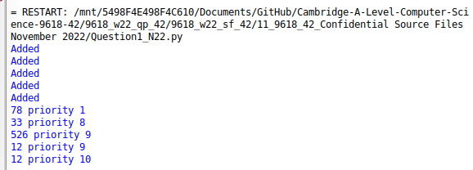

Question 2
Part 2(a)
{Copy and paste program code listing for Question 2(a) here}

Part 2(b)
{Copy and paste program code listing for Question 2(b) here}

Part 2(c)
{Copy and paste program code listing for Question 2(c) here}

Part 2(d)
{Copy and paste program code listing for Question 2(d) here}

Part 2(e)
{Copy and paste program code listing for Question 2(e) here}

Part 2(f)
{Copy and paste program code listing for Question 2(f) here}

Part 2(g)(i)
{Copy and paste program code listing for Question 2(g)(i) here}

Part 2(g)(ii)
{Copy and paste the screenshot for Question 2(g)(ii) here}

Question 3
Part 3(a)
{Copy and paste program code listing for Question 3(a) here}

Part 3(b)
{Copy and paste program code listing for Question 3(b) here}

Part 3(c)
{Copy and paste program code listing for Question 3(c) here}

Part 3(d)
{Copy and paste program code listing for Question 3(d) here}

Part 3(e)(i)
{Copy and paste program code listing for Question 3(e)(i) here}

Part 3(e)(ii)
{Copy and paste the screenshot for Question 3(e)(ii) here}

